**Lab Assignment – Enterprise IAAA Part 3 (Accountability)**

**Guideline:**

* You are **ALLOWED** to reference the course materials and online content to complete the lab.
* It is your responsibility to **BACKUP** your virtual machine(s) to your external drive.
* **FOLLOW** the instructions outlined in this document to avoid losing marks.

**Deliverables**

* Provide answers for questions outlined in the last page of this document. The answers will be in a form of screenshots that shows the configuration. Make sure the screenshots are visible and clear before uploading and submitting to Brightspace.

**Audit Policy Configuration**

* + Enable success and failure attempts for Audit object access policy settings on the domain controller
  + Set the auditing rules on Accounts Payable folder to Everyone group on all permissions
  + Set the auditing rules on Accounts Receivable folder to Everyone group on all permissions

**Audit Activities**

* + Login to Client01 using Henry Ford’s account and access Accounts Payable folder then attempt to access Accounts Receivable folder
  + Login to Client01 using Louis Chevrolet’s account and access Accounts Receivable folder then attempt to access Accounts Payable folder

**Questions**

**Note: Provide screenshots for below requirements as evidence of your configuration. Editing/cropping screenshots will not be accepted**

**Question #1 in windows server 2019, how to access the GPO setting to check the audit object access?**

**>> go to Server Manager >> Tools >> Group Policy Management (GPO)**

**Question #2 - #5**

**>> Server Dashboard >> Tools >> Event Viewer**

1. Login to your AD domain controller and open the GPO settings and take a screenshot of the configuration made to enable the success and failure of Audit Object Access and save it as jpeg file.

1. Login to your AD domain controller and open the event viewer and located the success action taken by Henry Ford’s account. Open the event and take a screenshot the save it as jpeg file.

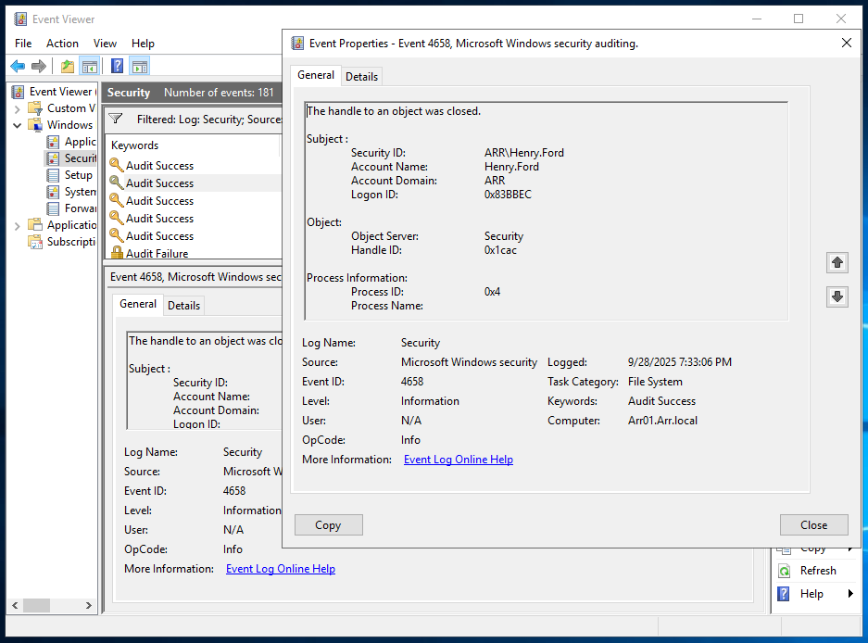

1. Login to your AD domain controller and open the event viewer and located the failed action taken by Henry Ford’s account. Open the event and take a screenshot the save it as jpeg file.

1. Login to your AD domain controller and open the event viewer and located the success action taken by Louis Chevrolet’s account. Open the event and take a screenshot the save it as jpeg file.

1. Login to your AD domain controller and open the event viewer and located the failed action taken by Louis Chevrolet’s account. Open the event and take a screenshot the save it as jpeg file.

**Marking Guide**

Each screenshot should show the configuration you have made. The grades are divided equally among all requirements. Each answer is worth 2% out of 10%. No partial marks on individual requirement.

|  |  |  |  |
| --- | --- | --- | --- |
| Deliverables | (Yes / No) | Feedback | Marks (2% Each) |
| GPO policy configuration |  |  |  |
| Success event of Henry’s action |  |  |  |
| Failed event of Henry’s action |  |  |  |
| Success event of Louis’s action |  |  |  |
| Failed event of Louis’s action |  |  |  |

**Submission**

You are required to submit the following in a single zip folder

1. A single screenshot for requirement 1, 2, 3, 4, and 5. (Total of 5 screenshots)
2. All above submissions must be saved in a folder then zipped and uploaded to Lab 1 – Part 3 (Accountability) on Brightspace.